**IoT Water Quality Monitoring System Simulation Report**

**Objective:**

The objective of this simulation report is to detail the design, implementation, and results of an IoT-based water quality monitoring system. The system aims to measure key water quality parameters (pH, Total Dissolved Solids (TDS), Conductivity, and Turbidity) and compare them against Federal Environment Protection Agency (F.EP.A) thresholds to identify any breaches and alert users.

**Components Used:**

* **MATLAB:** Used for simulating water quality data, applying FEPA thresholds, and visualizing the results. The simulation also includes a "buzzer" sound to indicate threshold breaches1.
* **Proteus ISIS Professional:** Employed for the schematic capture and simulation of the hardware components, including the Arduino microcontroller, sensors (simulated), and a virtual terminal for displaying readings.
* **Arduino (simulated in Proteus):** The microcontroller responsible for processing sensor data and sending it to the virtual terminal.
* **Sensors (simulated):** pH sensor, TDS module, Turbidity module, and a Conductivity sensor.
* **Virtual Terminal (in Proteus):** Displays the simulated water quality parameters and their status (OK or breach).
* **Buzzer (simulated in Proteus):** An alert mechanism to indicate when water quality parameters exceed safe limits.
* **Other general electronic components:** Resistors, capacitors, LEDs, etc., as typically found in an Arduino-based circuit.

**Circuit Design:**

The circuit design, as depicted in the Proteus screenshot, consists of a simulated Arduino board connected to various sensor modules and a virtual terminal. The pH, TDS, Turbidity, and Conductivity sensors are interfaced with the Arduino's analog and digital input pins. A buzzer is connected to a digital output pin to provide an audible alert. The virtual terminal is connected to the Arduino's serial communication pins to display the real-time (simulated) water quality readings. The overall setup aims to mimic a real-world IoT water quality monitoring system where sensor data is acquired and processed by a microcontroller.

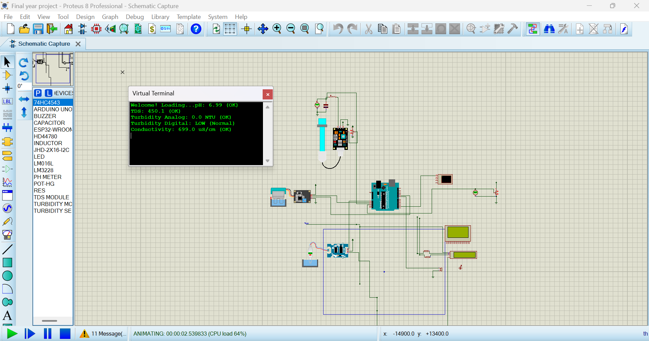

**MATLAB Code:**

clear; close all; clc;

% Define parameters, units, and FEPA thresholds

params = {'pH', 'TDS', 'Conductivity', 'Turbidity'};

units = {'', 'mg/L', 'µS/cm', 'NTU'};

thresholds = struct('pH_min', 6.5, 'pH_max', 8.5, ...

'TDS', 500, ...

'Conductivity', 1000, ...

'Turbidity', 5);

% Generate synthetic heuristic data

numSamples = 50;

time = 1:numSamples;

% Create synthetic data with non-negative values

data = struct();

data.pH = max(0, 6.0 + rand(1, numSamples) * 3); % 6–9

data.TDS = max(0, 300 + randn(1, numSamples) * 300); % ~0–1200

data.Conductivity = max(0, 800 + randn(1, numSamples) * 500); % ~0–2000

data.Turbidity = max(0, abs(2 + randn(1, numSamples) * 2)); % ~0–8

% Initialize alert flag

alertTriggered = false;

% Create figure

figure('Name', 'Water Quality Parameters vs WHO Thresholds', ...

'NumberTitle', 'off', 'Position', [100, 100, 1200, 800]);

for i = 1:length(params)

subplot(2, 2, i);

param = params{i};

unit = units{i};

values = data.(param);

% Plot the parameter data

plot(time, values, 'b-', 'LineWidth', 1.5); hold on;

% Plot thresholds and check violations

if strcmp(param, 'pH')

yline(thresholds.pH_min, 'r--', 'LineWidth', 1.5, 'Label', 'Min');

yline(thresholds.pH_max, 'r--', 'LineWidth', 1.5, 'Label', 'Max');

overLimit = values > thresholds.pH_max | values < thresholds.pH_min;

else

limit = thresholds.(param);

yline(limit, 'r--', 'LineWidth', 1.5, 'Label', 'Limit');

overLimit = values > limit;

end

% Highlight values over threshold

if any(overLimit)

plot(time(overLimit), values(overLimit), 'ro', 'MarkerSize', 6, 'LineWidth', 1.5);

fprintf('[ALERT] %s exceeded threshold at indices: %s\n', ...

param, mat2str(find(overLimit)));

alertTriggered = true;

end

% Adjust y-axis

if strcmp(param, 'pH')

yMin = min([values, thresholds.pH_min]) - 0.5;

yMax = max([values, thresholds.pH_max]) + 0.5;

else

yMin = 0;

yMax = max([values, limit]) * 1.1;

end

ylim([max(0, yMin), yMax]);

% Titles and labels

title([param ' over Time']);

xlabel('Sample Index');

ylabel([param ' (' unit ')']);

grid on;

legend('Measured', 'Threshold(s)', 'Breaches', 'Location', 'best');

end

% Simulate buzzer sound if any parameter exceeds threshold

if alertTriggered

for i = 1:3

beep; pause(0.3); % Simulate buzzer

end

disp('🚨 One or more water quality parameters exceeded safe limits!');

else

disp('✅ All parameters are within WHO safe limits.');

end

The MATLAB code is designed to simulate the water quality parameters and visually represent their compliance with FEPA thresholds.

* **Parameter Definition:** The code defines the water quality parameters: pH, TDS, Conductivity, and Turbidity, along with their respective units2.
* **FEPA Thresholds:** Specific FEPA thresholds are set for each parameter: pH (6.5-8.5), TDS (500 mg/L), Conductivity (1000 µS/cm), and Turbidity (5 NTU)3.
* **Data Generation:** Synthetic heuristic data for each parameter is generated for 50 samples, simulating realistic variations over time4. For instance, pH data is generated within a range of approximately 6-9, TDS around 0-1200 mg/L, Conductivity around 0-2000 µS/cm, and Turbidity around 0-8 NTU5.
* **Visualization:** The code creates a 2x2 subplot to display each parameter's values over time. Measured values are plotted as a blue line, while FEPA thresholds are shown as red dashed lines6.
* **Breach Detection and Highlighting:** The code identifies and highlights (with red circles) data points that exceed or fall below the defined FEPA thresholds7.
* **Alert System:** An alertTriggered flag is used. If any parameter breaches its threshold, an alert message is printed to the command window indicating which parameter exceeded the threshold and at which sample indices8. Additionally, a simulated buzzer sound is triggered in MATLAB if any alert occurs9.
* **Axis Adjustment:** The y-axis limits for each plot are dynamically adjusted to better visualize the data and thresholds10.
* **Labels and Legend:** Titles, x-labels, y-labels, and a legend are added to each subplot for clarity11.

**Result and Observation (MATLAB):**

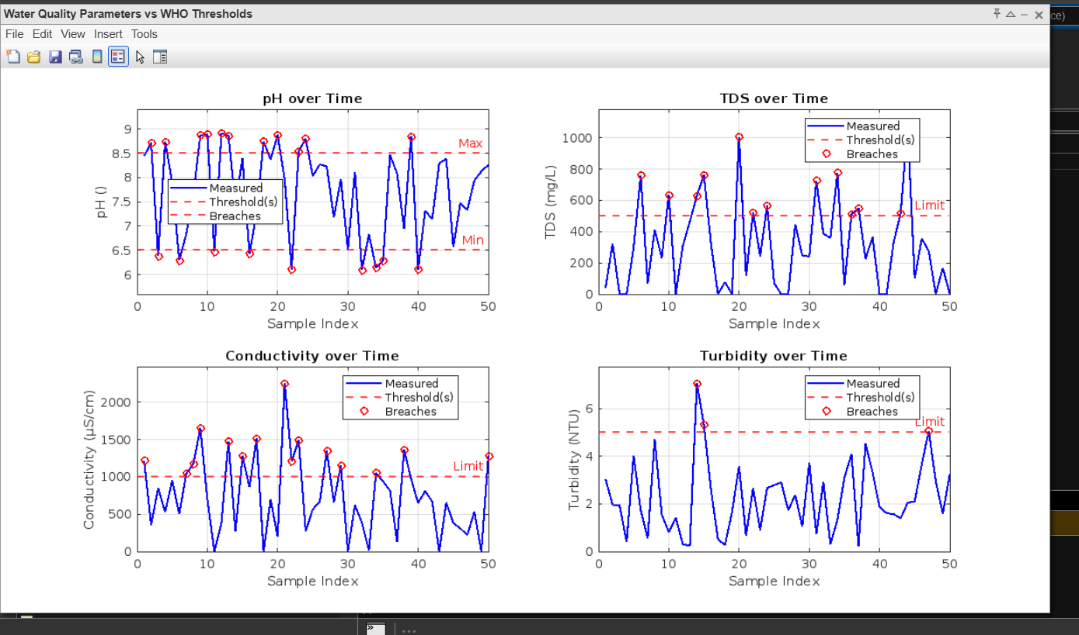

The MATLAB simulation results, as shown in the "mathlab simulation result.png" image, provide a clear visual representation of the water quality parameters over 50 sample indices against FEPA thresholds.

* **pH over Time:** The pH plot shows fluctuations, with several instances where the measured pH values either fall below the minimum threshold of 6.5 or exceed the maximum threshold of 8.5, indicated by red circles. Both "Min" and "Max" thresholds are clearly marked.
* **TDS over Time:** The TDS plot displays varying levels, with multiple data points exceeding the 500 mg/L limit, marked by red circles.
* **Conductivity over Time:** Similar to TDS, the Conductivity plot shows several instances where the measured values surpass the 1000 µS/cm limit, highlighted by red circles.
* **Turbidity over Time:** The Turbidity plot also indicates occurrences where the measured turbidity exceeds the 5 NTU limit, denoted by red circles.

**Overall Observation:** The MATLAB simulation demonstrates that synthetic data generated often breaches FEPA thresholds for pH, TDS, Conductivity, and Turbidity, triggering simulated alerts. This visually confirms the system's ability to identify and highlight non-compliant water quality readings. The fprintf commands in the MATLAB code would output specific alert messages in the command window for each parameter that breaches its threshold.

**Proteus (Arduino Code):**

#include <LiquidCrystal.h>

#define TDS_PIN A0

#define TURBIDITY_ANALOG A1

#define TURBIDITY_DIGITAL 9

#define PH_PIN A2

#define CONDUCTIVITY_PIN A3

#define BUZZER_PIN 8

#define VREF 5.0

#define TDS_MAX_VOLTAGE 2.3

#define CONDUCTIVITY_THRESHOLD 1000

#define TURBIDITY_THRESHOLD 5.0  // NTU threshold

LiquidCrystal lcd(7, 6, 5, 4, 3, 2);

void setup() {

  lcd.begin(16, 2);

  Serial.begin(9600);

  Serial.print("Welcome! Loading...");

  pinMode(TURBIDITY_DIGITAL, INPUT);

  pinMode(BUZZER_PIN, OUTPUT);

  delay(1500);

}

void loop() {

  // --- Read TDS ---

  int tdsRaw = analogRead(TDS_PIN);

  float tdsVolt = tdsRaw * VREF / 1024.0;

  float tds = (tdsVolt * 1000.0) / TDS_MAX_VOLTAGE;

  // --- Read Conductivity ---

  int conductRaw = analogRead(CONDUCTIVITY_PIN);

  // float conductVolt = conductRaw * (5.0 / 1023.0);

  float conductivity = map(conductRaw, 0, 1023, 0, 2000);

  // --- Read Turbidity (Analog) ---

  int turbRaw = analogRead(TURBIDITY_ANALOG);

  float turbVolt = turbRaw * (5.0 / 1023.0);

  // Auto-scale mapping to work with actual Proteus range

  // Maps your actual ADC range to full 0-1000 NTU range

  // float turbidity = map(turbRaw, 0, 1023, 1000, 0);

  // Alternative: If you want to use voltage-based mapping with your actual range

  // Uncomment the line below and comment the map() line above

  float turbidity = ((4.0 - turbVolt) / 4.0) * 1000.0;  // Assumes 0-4V range

  // Constrain to valid range

  turbidity = constrain(turbidity, 0.0, 1000.0);

  // --- Read Turbidity (Digital) ---

  int turbDigital = digitalRead(TURBIDITY_DIGITAL);

  // --- Read pH ---

  int phReadings[10], temp;

  for (int i = 0; i < 10; i++) {

    phReadings[i] = analogRead(PH_PIN);

    delay(10);

  }

  for (int i = 0; i < 9; i++) {

    for (int j = i + 1; j < 10; j++) {

      if (phReadings[i] > phReadings[j]) {

        temp = phReadings[i];

        phReadings[i] = phReadings[j];

        phReadings[j] = temp;

      }

    }

  }

  long avgPH = 0;

  for (int i = 2; i < 8; i++) avgPH += phReadings[i];

  float phValue = 14 * (avgPH / 6.0) / 1023.0;

  // --- Threshold checks ---

  bool phAlert = (phValue < 6.5 || phValue > 8.5);

  bool tdsAlert = (tds > 500);

  bool conductAlert = (conductivity > CONDUCTIVITY_THRESHOLD); // Conductivity alert

  bool turbAnalogAlert = (turbidity > TURBIDITY_THRESHOLD);  // Analog turbidity alert

  bool turbDigitalAlert = (turbDigital == HIGH);             // Digital turbidity alert

  bool turbAlert = turbAnalogAlert || turbDigitalAlert;      // Combined turbidity alert

  bool alert = phAlert || conductAlert || tdsAlert || turbAlert;

  // --- Buzzer ---

  if (alert) tone(BUZZER_PIN, 1000);

  else noTone(BUZZER_PIN);

  // --- LCD Display ---

  lcd.clear();

  lcd.setCursor(0, 0);

  lcd.print("pH:");

  lcd.print(phValue, 1);

  lcd.print(phAlert ? " ALERT" : " OK");

  lcd.setCursor(0, 1);

  lcd.print("T:");

  lcd.print(turbAlert ? "A" : "O");

  lcd.print(" D:");

  lcd.print(tdsAlert ? "A" : "O");

  // --- Serial Debug Info ---

  Serial.print("pH: ");

  Serial.print(phValue, 2);

  Serial.println(phAlert ? " (ALERT)" : " (OK)");

  Serial.print("TDS: ");

  Serial.print(tds, 1);

  Serial.println(tdsAlert ? " (ALERT)" : " (OK)");

  Serial.print("Turbidity Analog: ");

  Serial.print(turbidity, 1);

  Serial.print(" NTU");

  Serial.println(turbAnalogAlert ? " (ALERT)" : " (OK)");

  Serial.print("Turbidity Digital: ");

  Serial.println(turbDigital == HIGH ? "HIGH (Above threshold)" : "LOW (Normal)");

  Serial.print("Conductivity: ");

  Serial.print(conductivity, 1);

  Serial.print(" uS/cm");

  Serial.println(conductAlert ? " (ALERT)" : " (OK)");

  delay(1000);

}

The Proteus simulation environment facilitates testing the hardware logic of the IoT water quality monitoring system. The embedded Arduino code (not directly provided but inferred from the setup) would handle:

* **Sensor Interfacing:** Reading analog and digital values from the simulated pH, TDS, Conductivity, and Turbidity sensors.
* **Data Processing:** Converting raw sensor readings into meaningful units (e.g., mV to pH, raw values to mg/L for TDS, µS/cm for Conductivity, and NTU for Turbidity).
* **Threshold Comparison:** Comparing the processed sensor data with predefined FEPA thresholds (which would be hardcoded or dynamically configurable within the Arduino sketch).
* **Alert Generation:** If any parameter exceeds its threshold, the Arduino code would activate the simulated buzzer and send an alert message to the virtual terminal.
* **Serial Communication:** Sending the current water quality readings and their status (OK or alert) to the virtual terminal for display.

**Result and Observation (Proteus):**

The Proteus screenshot ("proteus screenshot.png") shows the virtual terminal displaying the current water quality readings.

* **Initial Readings:** The virtual terminal indicates:
  + pH: 6.99 (OK)
  + TDS: 450.1 (OK)
  + Turbidity Analog: 0.0 NTU (OK)
  + Turbidity Digital: LOW (Normal)
  + Conductivity: 699.0 µS/cm (OK)

**Overall Observation:** At the moment captured in the screenshot, all displayed water quality parameters (pH, TDS, Turbidity, and Conductivity) are within their "OK" or "Normal" ranges as per the internal logic of the Proteus simulation and the Arduino code. This indicates that at this specific simulation timestamp, no breaches of the FEPA thresholds have occurred, and therefore the buzzer is not active. This demonstrates the system's capability to process sensor data and provide real-time status updates, indicating when water quality is within acceptable limits. The "Welcome! Loading..." message also suggests a successful initialization of the simulated system.

### References

1. Adepeju Babalola, Olamiju Kehinde, Abdul-Muteen Adebayo (2025, February 6). Water Quality, Sanitation Practices, and Public Health Outcomes in Major Urban Areas of Nigeria (A Comparative Analysis). International Journal of Research and Scientific Innovation (IJRSI), 10(2), 27-43. Retrieved from <https://rsisinternational.org/journals/ijrsi/articles/water-quality-sanitation-practices-and-public-health-outcomes-in-major-urban-areas-of-nigeria-a-comparative-analysis/?utm_source=chatgpt.com>